Exercise

1 - Get all student from class A

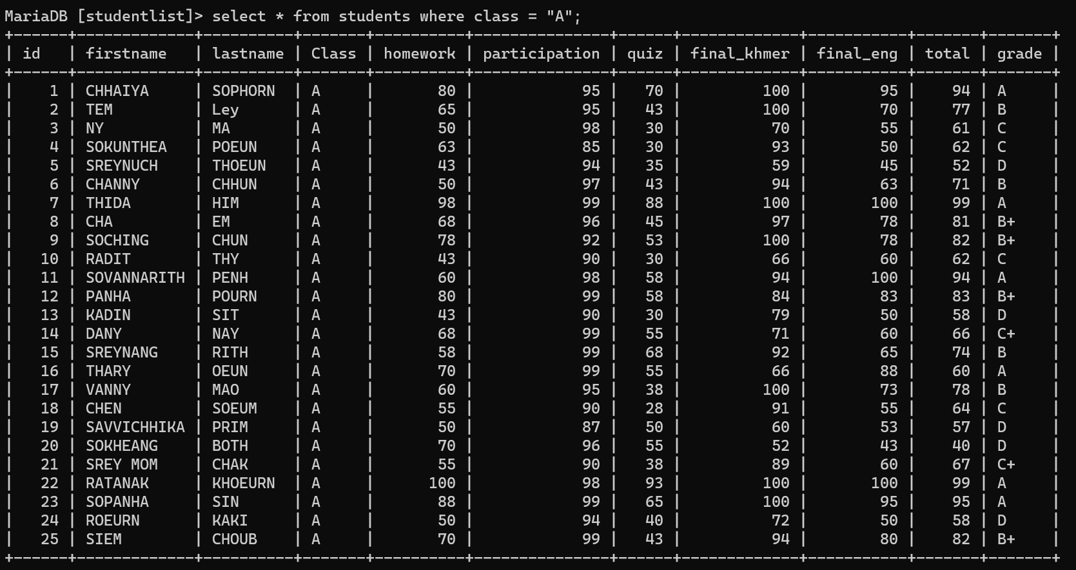

2 – Get all students who fail quiz from class C

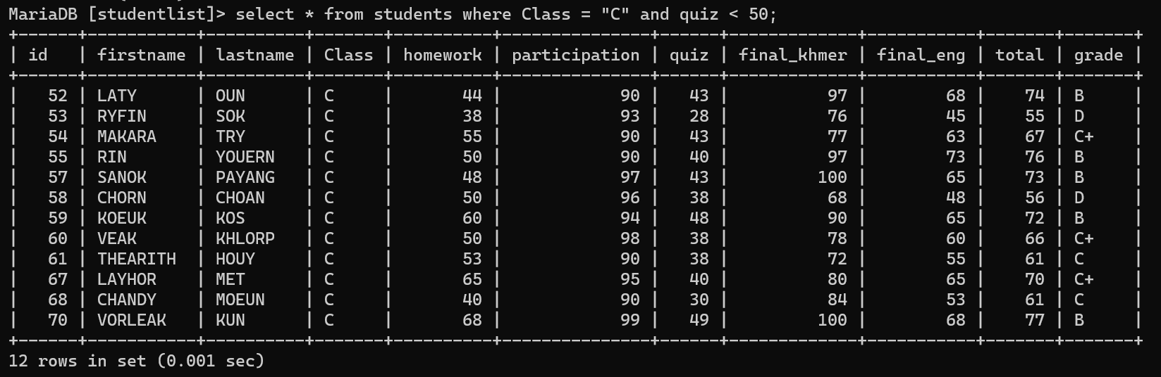

3 – Get all students who need to do make-up exams in all class

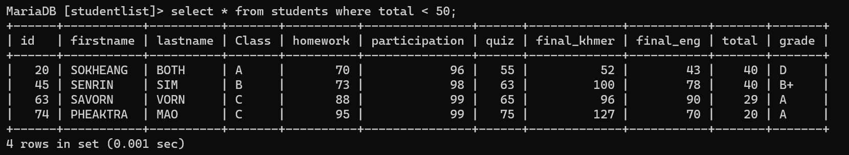

4 – Get all students who get scores between 80 – 100



5 – Get all students who have last name finished with the letter “N”



6 – Get all students who have first names start with the letter “S”



7 - Get all student who has grade A from class B to display only their first name, last name, and grade



8 – Sum all score for Voleak

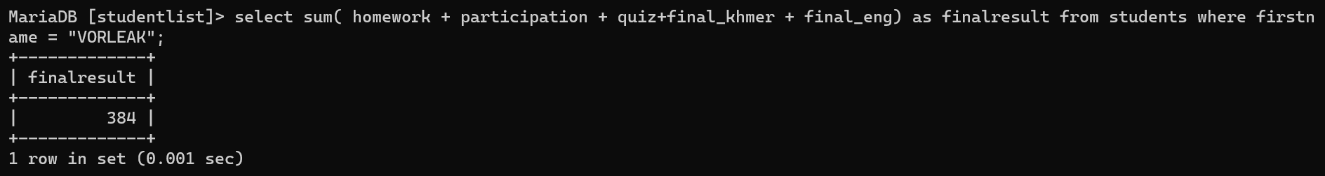

9 – Update Peaktra and Sanok from class C to B



10 – How many students get grades A



11 – Delete all students who failed the quiz



12 - merge firstname and lastname into one column



13 - Get the first 10 students from the list



14 – Get the average total score from the list



15 – Get all who have a total score less than the average score of the list



16 – Get all who have a total score equal maximum score in the list

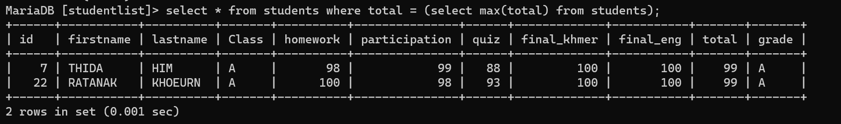

17 – Get all who have quiz scores equal minimum score quiz in the list

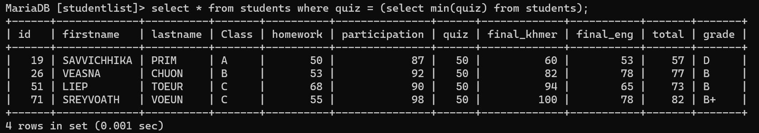

18 – Get all students who have maximum score equal total and quiz score less than average quiz score



19 – Get all students order lastname by desc



20 - Get a unique grade from the table

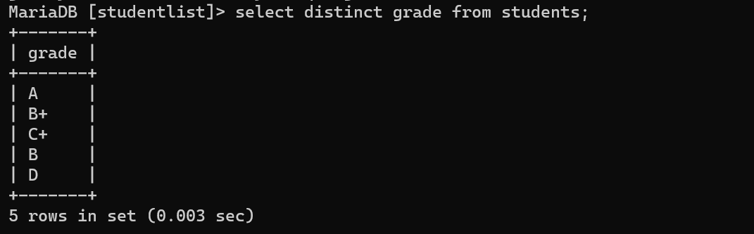

21 – Get firstname, lastname of students and group by class

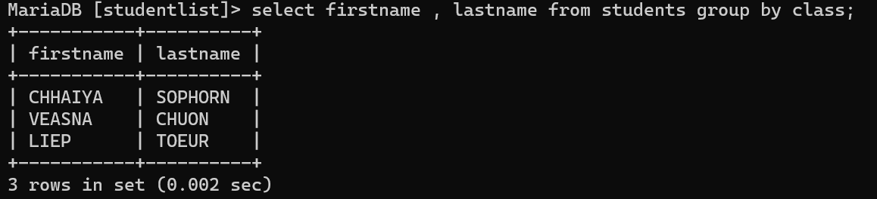

22 – Get full name, homework, quiz, total



23 – delete those who have lastname start with the letter “C”

